HTML Formatting

**Table of content**

* What is HTML formatting?
* What are the different types of text formatting use in HTML?
* How to change text format in HTML?

**What is HTML formatting?**

HTML formatting provides the ability to edit and format your text document with the help of formatting tags without using CSS (cascading style sheet). HTML formatting is use for making your text bold, italic, superscript, subscript and many more within the paragraph tag or heading tag respectively. HTML formatting is use for making your webpage and websites more attractive.

**Syntax-**

<html start tag> <formatting tag> your text </formatting end tag></html end tag>

**Example-**

<!DOCTYPE html>

<html>

  <head>

    <meta charset="UTF-8" />

    <title>Formating tag</title>

  </head>

  <body>

    <h1><b>GEEKY4U.com (learn with passion) </b></h1>

    <h2><i>GEEKY4U.com (learn with passion) </i></h2>

  </body>

</html>

**Output-**



**What are the different types of formatting use in HTML?**

**Use of Bold tag-**

In HTML document if you wish to highlight some content and make it as a bold then bold tag is used.

**Syntax-**

<html start tag> <b> your text </b></html end tag>

**Example-**

<!DOCTYPE html>

<html>

  <head>

    <meta charset="UTF-8" />

    <title>bold tag</title>

  </head>

  <body>

    <h1><b>GEEKY4U.com (learn with passion) </b></h1>

  </body>

</html>

**Output-**



**Strong / Important-**

Strong tag is use when we need to highlight some important content within the HTML document. In HTML Formatting, strong tag also works like a bold tag.

**Syntax-**

<html start tag> <strong > your text </strong ></html end tag>

**Example-**

<!DOCTYPE html>

<html>

  <head>

    <meta charset="UTF-8" />

    <title>strong tag</title>

  </head>

  <body>

    <p>GEEKY4U.com (learn with passion)-----------without using strong tag</p>

    <p>

      <strong>GEEKY4U.com (learn with passion)---------with strong tag</strong>

    </p>

  </body>

</html>

**Output-**

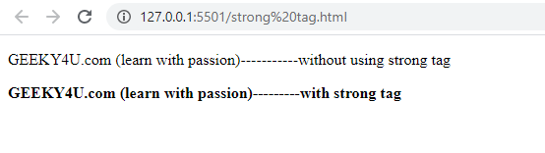

**Italic tag in HTML formatting-**

Italic tag in HTML formatting is use for making the text italic. Same as a bold tag italic tag is use inside the paragraph or heading tag.

**Syntax-**

<html start tag> <i> your text </i></html end tag>

**Example-**

<!DOCTYPE html>

<html>

  <head>

    <meta charset="UTF-8" />

    <title>bold tag</title>

  </head>

  <body>

    <h1><i>GEEKY4U.com (learn with passion) </i></h1>

  </body>

</html>

**Output-**

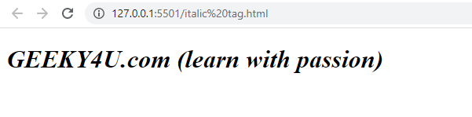

**Emphasized tag in HTML Style formatting-**

Emphasized tag is use for making text italic. Emphasis tag represented by <em> which is use within paragraph or heading tag.

**Syntax-**

<html start tag> <em> your text </em></html end tag>

**Example-**

<!DOCTYPE html>

<html>

  <head>

    <meta charset="UTF-8" />

    <title>em tag</title>

  </head>

  <body>

    <h1><i>GEEKY4U.com (learn with passion) </i></h1>

  </body>

</html>

**Output-**

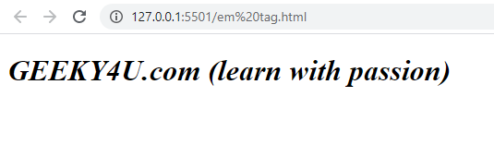

**Marked tag in HTML Formatting-**

Mark tag is use for marking the very important text within the HTML document.

**Syntax-**

<html start tag> your text <mark tag> mark your imp text </mark tag> your text</html end tag>

**Example-**

<!DOCTYPE html>

<html>

  <head>

    <meta charset="UTF-8" />

    <title>mark tag</title>

  </head>

  <body>

    <h2><mark>GEEKY4U.com </mark>(learn with passion)</h2>

  </body>

</html>

**Output-**



**Smaller tag in HTML Formatting-**

Smaller tag is use for making the HTML text small.

**Syntax-**

**Example-**

<!DOCTYPE html>

<html>

  <head>

    <meta charset="UTF-8" />

    <title>small tag</title>

  </head>

  <body>

    <p>GEEKY4U.com (learn with passion)</p>

    <p><small>GEEKY4U.com (learn with passion) </small></p>

  </body>

</html>

**Output-**

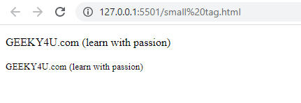

**Delete tag in HTML formatting-**

This tag is use to represent the deleted element from your HTML text document. For representing the deleted element, the browser will show strike line over the deleted text. Delete tag is represented by <del>

**Syntax-**

<html start tag> your text<del> your text </del>your text</html end tag>

**Example-**

<!DOCTYPE html>

<html>

  <head>

    <meta charset="UTF-8" />

    <title>del tag</title>

  </head>

  <body>

    <h1>GEEKY4U.com (learn with passion) <del>(learn with passion)</del></h1>

  </body>

</html>

**Output-**

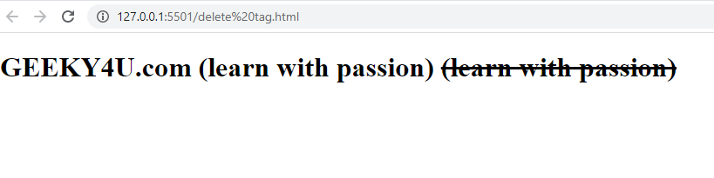

**Inserted Tag in HTML Formatting-**

Inserted tag in HTML formatting will help to display an inserted text. If you use delete tag then it will display strike and at the same time if you use insert tag then browser will automatically create one underline to the inserted element.

**Syntax-**

<html start tag> your text<del> your text </del>your text<ins> your inserted text</ins></html end tag>

**Example-**

<!DOCTYPE html>

<html>

  <head>

    <meta charset="UTF-8" />

    <title>ins tag</title>

  </head>

  <body>

    <h1>

      GEEKY4U.com <del>(learn with passion)</del><ins>(learn with passion)</ins>

    </h1>

  </body>

</html>

**Output-**



**Subscript tag in HTML formatting-**

**HTML formatting supports to the subscript tag. This tag will make the text in subscript means come text is in the normal line and some will below the normal line. Tag use to represent the subscript tag is <sub>.**

**Syntax-**

<html start tag> your text<sub> your text </sub>your text</html end tag>

**Example-**

<!DOCTYPE html>

<html>

  <head>

    <meta charset="UTF-8" />

    <title>subscript tag</title>

  </head>

  <body>

    <h1>GEEKY4U.com  <sub>(learn with passion)</sub></h1>

  </body>

</html>

**Output-**

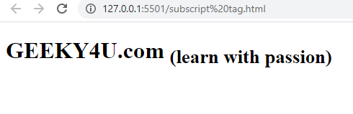

**Superscript-**

**HTML formatting also supports to the superscript tag. This tag will make the text in superscript means come text is in the normal line and some will above the normal line. Tag use to represent the superscript tag is <sup>.**

**Syntax-**

<html start tag> your text<sup> your text </sup>your text</html end tag>

**Example-**

<!DOCTYPE html>

<html>

  <head>

    <meta charset="UTF-8" />

    <title>superscript tag</title>

  </head>

  <body>

    <h1>GEEKY4U.com  <sup>(learn with passion)</sup></h1>

  </body>

</html>

**Output-**

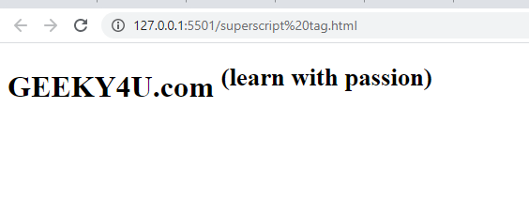

**How to change text format in HTML?**

We can change the text format of the HTML text document by using Inline text element. The inline element in the tag will supports to the paragraph as well as heading tag with the help of some CSS property like font-family, font size or font color.

**Example-**

<!DOCTYPE html>

<html>

  <head>

    <title>inline style</title>

  </head>

  <body>

    <h1 style="background-color: rgba(94, 243, 243, 0.356)">

      GEEKY4U.com(learn with passion)

    </h1>

    <h2 style="background-color: rgb(88, 236, 175)">

      GEEKY4U.com(learn with passion)

    </h2>

    <p style="background-color: rgb(193, 226, 46)">

      GEEKY4U.com(learn with passion)

    </p>

  </body>

</html>

**Output-**

